**Assessment Cover Sheet- Institute of ICT**

|  |  |  |  |  |  |  |
| --- | --- | --- | --- | --- | --- | --- |
| Course Title | Advanced Diploma in IT | | Unit Number & Title | | ITSFT-406-1502Software/Multimedia Project | |
| Lecturer | Elaine FarrugiaGerard Said | | Assignment Title | | Project | |
| Verified by | **Carlo Mamo** | | Date | |  | |
| Date Set | **19/02/2018** | | Deadline Date | | 25/05/2018 | |
| Class/group | **Please tick as appropriate:**  **IT-SWD-4.2A**  **IT-SWD-4.2B**  **IT-SWD-4.2C**  **IT-SWD-4.2D**  **IT-MSD-4.2A**  **IT-MSD-4.2B**  **IT-MSD-4.2C** | | Academic Year | | 2017-2018 | |
| Student Name |  | | ID Number | |  | |
| Student’s declaration prior to hand-in I certify that the work submitted for this assignment is my own; and that I have read and understood MCAST/the College’s copying and plagiarism policy. | | | | | | |
| Student’s declaration on assessment special arrangements: LEAVE BLANK IF NOT APPLICABLE  I certify that adequate support was given to me during the assignment through the Institute and/or the Inclusive Education Unit.  I declare that I refused the special support offered by the Institute. | | | | | | |
| Student Signature: | |  | | Date : | |  |

|  |  |  |
| --- | --- | --- |
| Assessment Parameters | Max Mark | Marks Achieved |
| AA1 Analyse and interrogate a brief based on previous learning  AA2 Produce a requirements analysis  KU1 Identify and consider target audience  KU2 Record project scope and plan tasks within timescale  AA3 Produce a planning document  AA4 Prepare and produce a planning schedule  KU3 Identify appropriate design principles  SE1 Design a solution based on a brief  KU4 Show implementation of chosen solution using appropriate development tools  KU5 Test the solution effectively  KU6 Examine and monitor project process  KU7 Examine and modify project plan accordingly dependent on progress  SE2 Evaluate product in terms of meeting required aims  AA5 Assess whether product met required objectives  KU8 Review and reflect on personal strengths  KU9 Review and reflect on personal weaknesses    Total Assignment Mark | 7  7  5  5  7  7  5  10  5  5  5  5  10  7  5  5  100 |  |

|  |  |  |  |
| --- | --- | --- | --- |
| **Feedback** | | | |
|  | | | |
| **Learner signature** |  | **Date** |  |
| **Assessor signature** |  | **Date** |  |
| **Internal Verifier** |  | **Date** |  |

|  |  |  |  |
| --- | --- | --- | --- |
| **Verifier Comments** | | | |
|  | | | |
| **Verifier Name** |  | **Date** |  |
| **Verifier Signature** |  |  |  |

**ITPRJ-406-1502: Software/Multimedia Project**

**Project**

**2017-2018**

**Marking Scheme**:

|  |  |  |  |  |
| --- | --- | --- | --- | --- |
| AA1, AA2, KU1 – *Proposal Document (Milestone 1)* | | | 19 marks | |
| KU2, AA3, AA4, KU3, SE1 – *Planning/Design Document (Milestone 2)* | | 34 marks | | | |
| KU4, KU5, KU6, KU7 – *Implementation, Testing and Review (Milestone 3)* | | | 20 marks | |
| SE2, AA5, KU8, KU9 – *Evaluation (Milestone 3)* | | | 27 marks | |
| **Total:** | **100 marks** | | |

**Guidelines** (please read):

* This assignment requires tasks that need to be started at the beginning of the software engineering process and need to be continued consistently throughout. Therefore it is suggested that you read all the assignment beforehand.
* Your lecturer will guide you towards multiple deadlines so that different parts of the assignment are handled in milestones. This will help you organise your time better and gain more out of this unit. Remember that software engineering is a complicated process which requires months. Attempting to do the assignment in a few days/weeks is unacceptable.
* If you use any resources (including the internet) in order to complete your assignment, these must be referenced. Copying from such sources or from other students will result in the enforcement of the current disciplinary procedures. If the sources are correctly referenced but the material is used without being understood and adapted, such disciplinary procedures may still be enforced.
* Submission details will be communicated by your lecturer before each milestone. Note that each milestone is a requirement for the next one. For example Milestone 1 is a requirement when submitting Milestone 2, etc…
* Note that assignments handed in without the assignment cover sheet will be considered as not submitted.
* The deadline of the last milestone is **25th May, 2018**.

**Software/Multimedia Project 2017-2018**

**Advanced Diploma Year 2**

**Milestone 2 - Planning and Design Document**

**Name:** ____________________________ **Group:** ________________

**Date Submitted:** ____________________

***KU2 – Record project scope and plan tasks within time scale (5 marks)***

1. List the **Resources** you need to complete your project (the number of resources required depends on your project). This includes equipment, software, assets, etc… (1 mark)
2. Visual studio
3. Brackets
4. Xampp
5. Basic hardware
6. Bootstrap
7. Owl carousel 2

1. List **2 topics/aspects** you need to research or practice more in order to have enough skills to complete your project. (1 mark)
2. Connecting to the database and handling it with PHP
3. Find a way to create a ticket or fill a ticket
4. List and explain **1 risk** that can happen during the process of carrying out your project, and what you plan to do in case it actually happens. (1 mark)

**Not being able to finish in time**

One risk that can happen during the project is that I would use time in some tasks and lose time or having a problem with the software and it will take me more time to fix it then to program and for the first precaution I have planned for not losing time is that I shell evaluate every fetcher and give each fetcher a date and time in which I will only do that specific function, the second precaution I will take is that I shell install all the programmes needed for my project and testing them and also trying out that the school pc programs and my home PC programmes are compatible.

1. Mention an **existing system** the aims of which are similar to yours. Explain some of the most important and/or interesting features it has. (2 marks)

An existing system that is similar to mine is a web said called ticket line (Link: <https://www.ticketline.com.mt>) that you can buy tickets online instead of going to the place and buying tickets by hand, feathers that are important like buying the ticket online and if it is a teather event you can choose the seats that will be sited in, and the ability to receive the email online.

***AA3 – Produce a planning document (7 marks)***

1. In this section you will be planning your testing strategy.
2. Plan and explain the testing strategy for your **web application**. Keep in mind the following points:

* What testing methodology and levels of testing will you be using throughout development and after development of your web application? (2.5 marks)
* What data will you use as part of your testing? (1 marks)

The web application will be tested on performance methodology which i will test that the stretcher of the website will be stabile for the functions that are required ,for a level of testing I will use unit testing and also integration testing, unit testing will be used to see that the function gives the intended output and integration testing to see if it would effect the other functions of the program. To test the web application I would use dummy data and even function has it’s own dummy data, the login function will be given no existing username and password and existing username and password, the buying function will be given numbers where sting is Sipos to be accepted and sting where numbers should be accepted to see that all inputs are valid.

1. Plan and explain the testing strategy for your **desktop/mobile application**. Keep in mind the following points:

* What testing methodology and levels of testing will you be using throughout development and after development of your desktop/mobile application? (2.5 marks)
* What data will you use as part of your testing? (1 marks)

testing I will use unit testing and also integration testing, unit testing will be used to see that the function gives the intended output and integration testing to see if it would effect the other functions of the program.

***AA4 – Prepare and produce a planning schedule (7 marks)***

1. Divide the work that needs to be done into smaller tasks. Do not forget to include tasks which are not explicitly part of the system (such as testing and documentation). You can start from the next milestone after this one, i.e. Design/Modelling. (3 marks)
2. Designing the website
3. Designing the desktop application
4. Creating the database and filing in the tables.
5. Add the Add ,Change, Delete and show fetcher to the desktop application
6. Add the Add ,Change, Delete and show fetcher to the web application
7. Implement the authorisation log in for the Desktop application.
8. Implement the authorisation log in for the web application.
9. Start building the buy featcher.
10. Implementing the QR cod
11. Sending the ticket by email
12. Sending the details of the people that had bout a ticket
13. With every task I will check immediate after the implementation to check that it works with the system
14. Create a **weekly Gantt chart** to depict the schedule of completing the tasks outlined in question 6). You can assume a period of 8 or *9 weeks*. It is recommended to use *Microsoft Project* to create the chart. Attach the chart with this document. (4 marks)

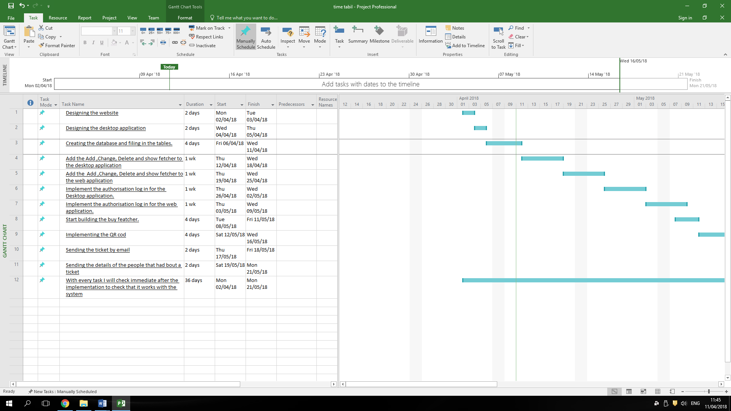

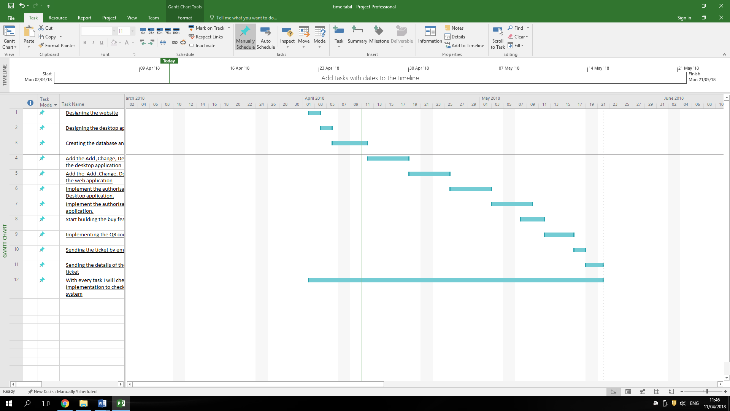

***SE1 – Design a solution based on a brief (10 marks)***

1. If your solution **includes** a database:

a) For **3** interactions in your application, create a flowchart or a UML Activity diagram showing the workflow/activity-flow in detail. Complete diagrams, abiding with correct notations are required. (6 marks)

1. Create an ERD showing the design of your database. Make sure your database is well-designed and normalised. (4 marks)

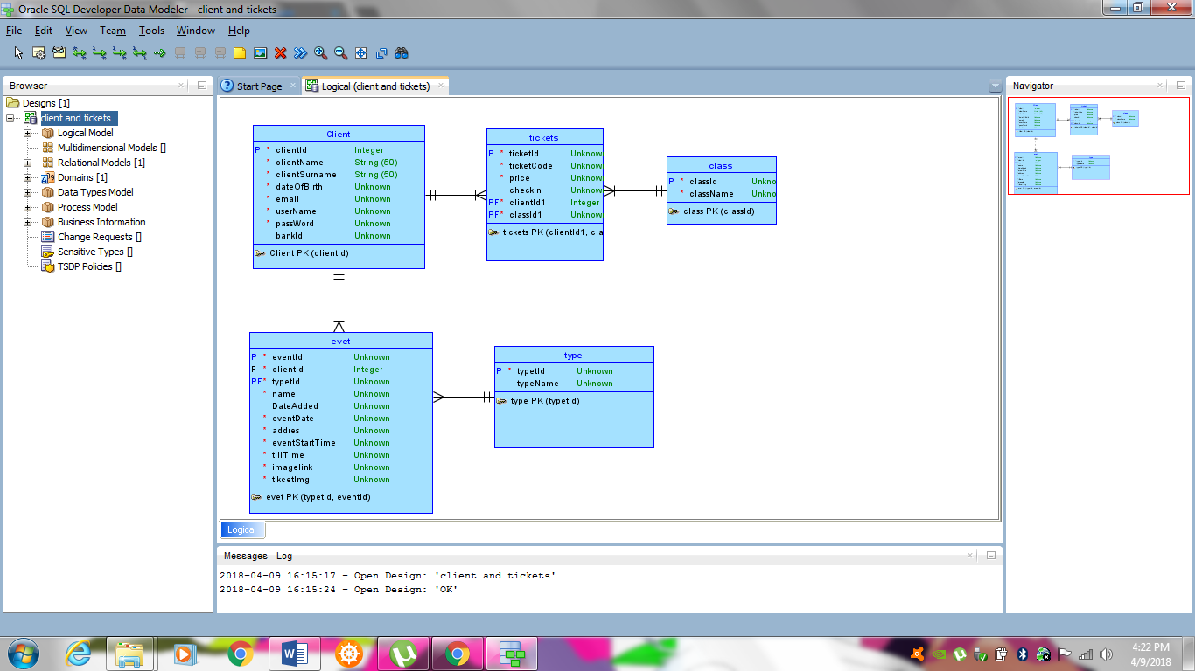

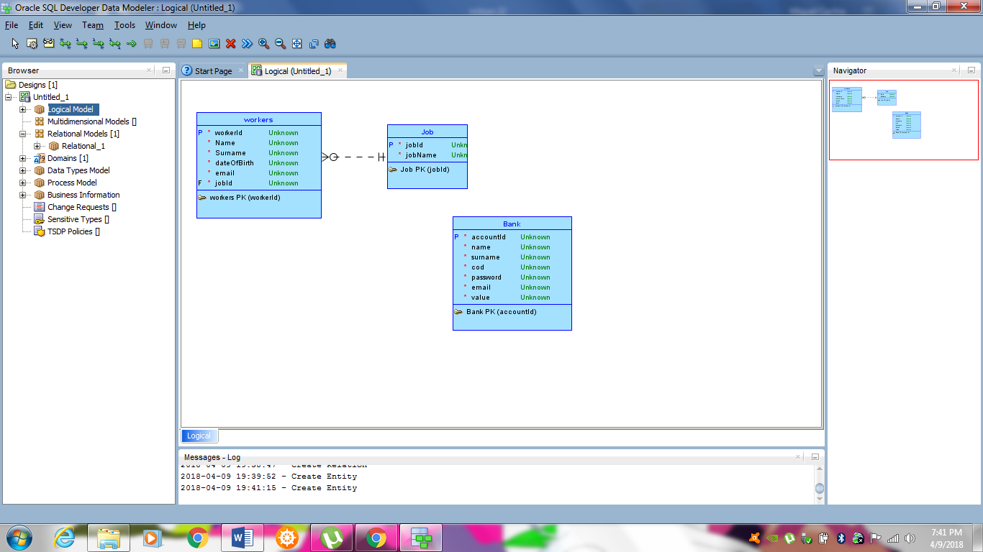

**Log In Web**

**C:\Users\Miguel\Downloads\Untitled Diagram.png**

**Search**

C:\Users\Miguel\Downloads\serch.png

**Buying**

C:\Users\Miguel\Downloads\Untitled Diagram (1).png

If your solution **does not include** a database:

a) For **5** interactions in your application, create a flowchart or a UML Activity diagram showing the workflow/activity-flow in detail. Complete diagrams, abiding with correct notations are required. (10 marks)

***KU3 – Identify appropriate design principles (5 marks)***

1. Explain 5 specific design considerations that you took during the project. This can refer to the UI of the web application, the UI of the mobile/desktop application, or the logo/poster (1 mark each).
2. In the website I have tried to use a colour scheme so that the colours would not be unlatching and be pleasant for the user ,posters are not part of this consideration
3. In the website I would make that when the scream minimalizes the amount of events in one line would decries
4. The important button functionality I’ve put them in a visible position and with a colour that immediately catches the eye.
5. I have used a basic ley out which is navigation bar new events and below a basic list of events in general.
6. I’ve tried to make the website as clean as possible for example al make use of a drop down function for the login.

***Version Control System (Required)***

1. Write down the link to the repository you will be using for this project. You are expected to assign your lecturer as an *admin* on this repository.

https://github.com/b42009/miguel-cachia-4.2A-progect.git

For lecturer’s use only:

□ Planning/Design Form accepted without modification

□ Planning/Design Form accepted with modification request Deadline: _______________

□ Planning/Design Form rejected Deadline: _______________

Lecturer’s comments:

_________________________________________________________________________________

__________________________________________________________________________________________________________________________________________________________________

_________________________________________________________________________________

_________________________________________________________________________________

Lecturer: ___________________________

Lecturer’s Signature: ___________________________

Date: ______________________

*In case of final version:*

|  |  |  |
| --- | --- | --- |
| **Criteria** | **marks achieved** | **out of** |
| KU2 - Record project scope and plan tasks within timescale |  | *5* |
| AA3 - Produce a planning document |  | *7* |
| AA4 - Prepare and produce a planning schedule |  | *7* |
| KU3 - Identify appropriate design principles |  | *5* |
| SE1 - Design a solution based on a brief |  | *10* |
| *Total:* |  | *34* |

*-------------------------------------------End of Planning/Design Document----------------------------------------------*